Intelligence Inference Engine

Installation Guide

Table of Contents
Table of Contents
Table of Contents 2
Introduction 3
System Requirements 4
Verify Correct Package 5
Setup Instructions (Easy DEV PHP) 6
Setup Instructions (Intelligence Inference Engine) 13
Setup Instructions (MySQL Setup) 17
Closing Remarks 22

Introduction

Good day, if you are reading this, you have downloaded the Intelligence Inference Engine and are on your way to installing our product. We're very happy you chose us to be your search engine provider among all of the other existing technologies that exist in the marketplace and are more than happy to provide our software and our source code under the CC0 license. Please read through this guide to ensure our software is correctly installed for your use and if you have any further questions, please don't hesitate to contact as at our educational email (lherr012@fiu.edu / jacosta046@fiu.edu)

System Requirements

During the development of this software product, we utilized this as our development machine for hosting.
- OS: Windows 7
- CPU: 1 Core (Xeon)
- RAM: 2 GB
- HD: 30 GB

Aside from the software that will be installed as part of this guide, you will also require
- Java 7 (or compatible version)

Verify Correct Package

The Intelligence Inference Engine may ship in multiple configurations but we should verify the package contents for the version you downloaded.

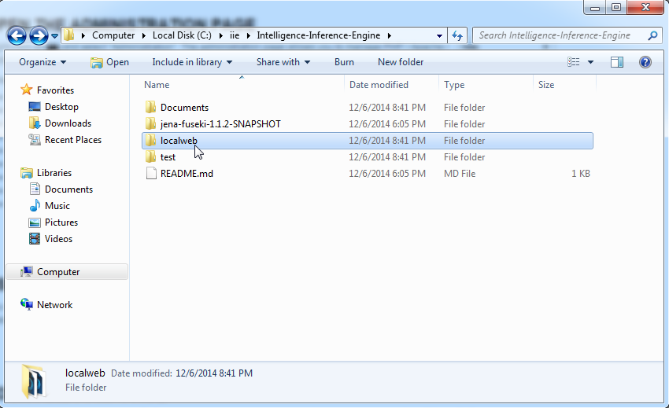
Here is the most common configuration

The breakdown for files is as follows
1) Documents – These include any documentation for this software
2) jena-fuseki-1.1.2-SNAPSHOT – The core of the semantic web searching engine
3) localweb – The code to be deployed to a server
4) test – The set of test cases that can be used to verify basic usability.

Setup Instructions (Easy DEV PHP)

Tip: You can utilize any off-the-shelf hosting solution but during our development process, EasyDEVPHP was the WAMP stack utilized. Although it greatly sped up the creation of this software product, it is neither required nor recommended that you run a production-level server with this software product.(http://www.easyphp.org/save-easyphp-devservervc11-latest.php)
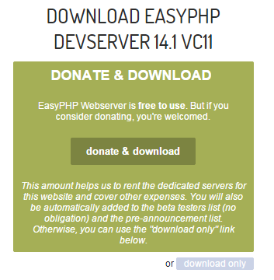

Step 1: Download EasyPHP DevServer

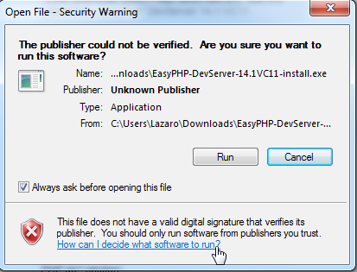

Step 2: Run the downloaded file
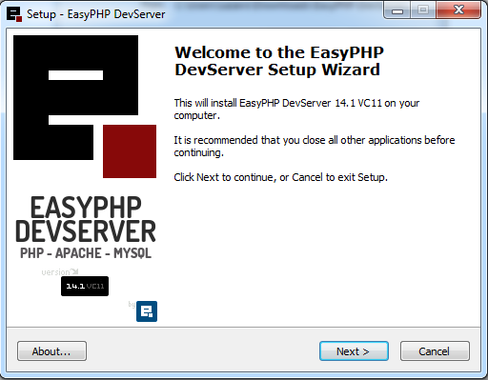

Step 3: Click Next to begin your installation

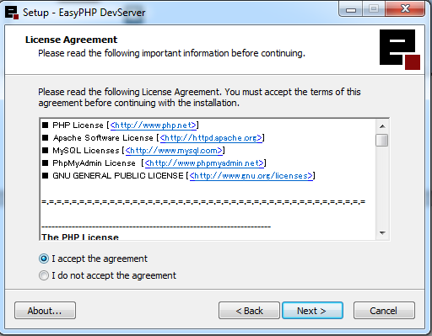

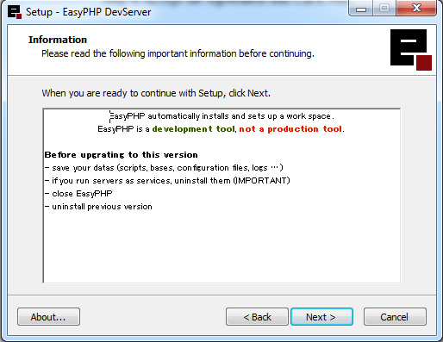
Step 4: Accept the Agreement and Click Next

Step 5: Click Next to continue
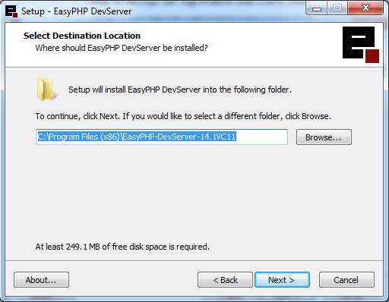

Step 6: Select your installation location
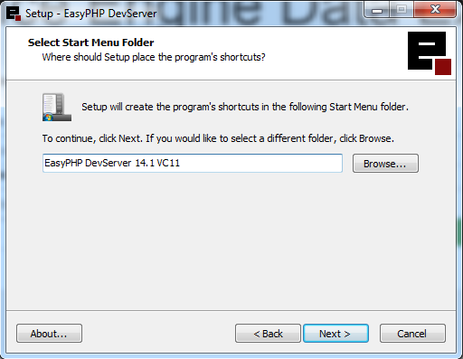

Step 7: Name the installation on the Start Menu
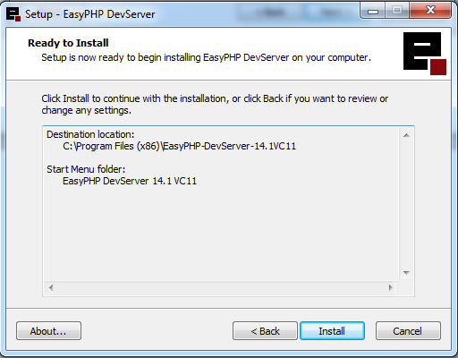

Step 8: Press Install to begin the installation
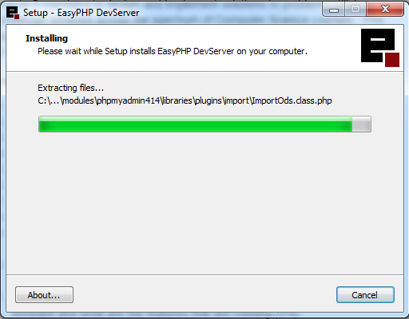

Step 9: Get a cup of your favorite work-appropriate beverage
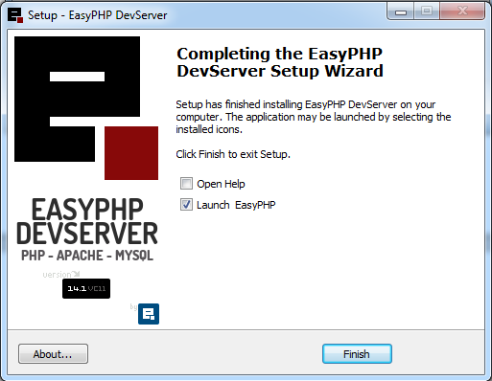

Step 10: Untick Open Help and Click Finish

Setup Instructions (Intelligence Inference Engine)

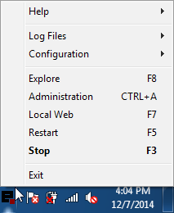

Step 1: Right Click on the EasyDEVPHP Logo and click on Explore
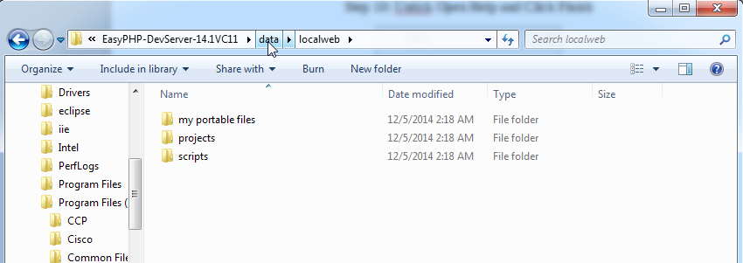
Step 2: Go up one level to the “data” folder.
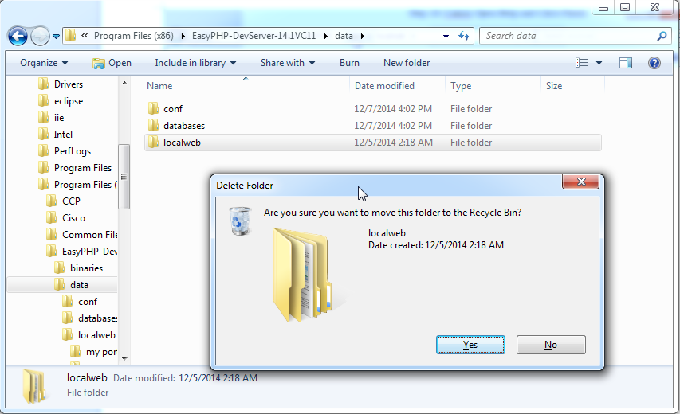
Step 3: Delete the localweb folder and move the one from our package over
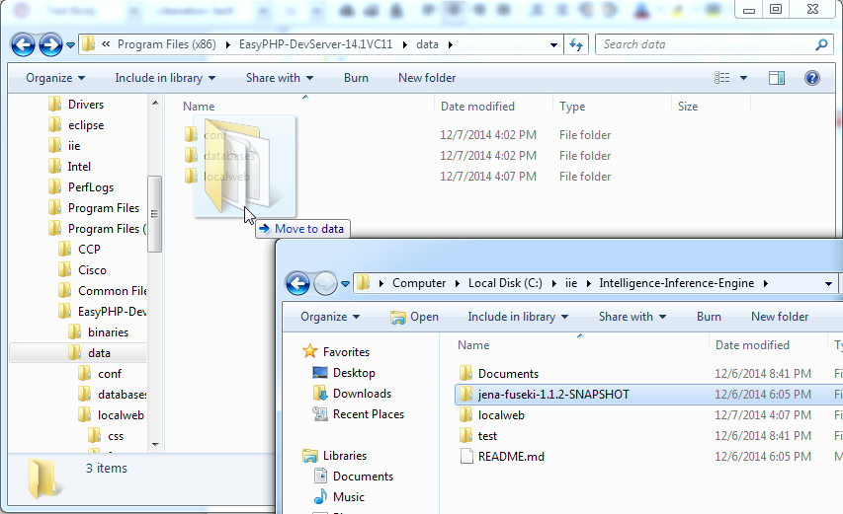
Step 4: Move the jena-fuseki-1.1.2-SNAPSHOT folder from deployment package to the data folder.

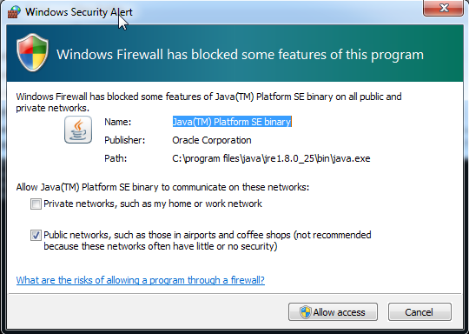
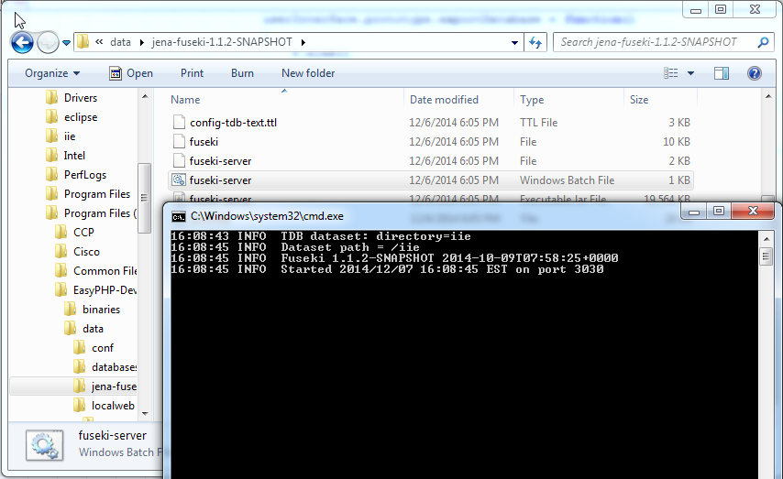
Step 5: Open the jena-fuseki-1.1.2-SNAPSHOT folder and double-click on fuseki-server

Step 6: When prompted, Allow Access for Java

Setup Instructions (MySQL Setup)

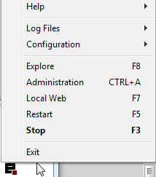

Step 1: Right Click on the EasyDEV logo and click on Administration
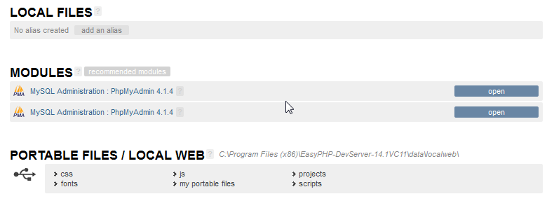
Step 2: Click on the first “open” button of MySQL Administration

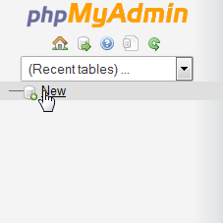

Step 3: Click “New” to create a new table.
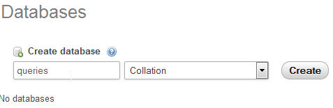

Step 4: Fill in “queries” and click “Create”
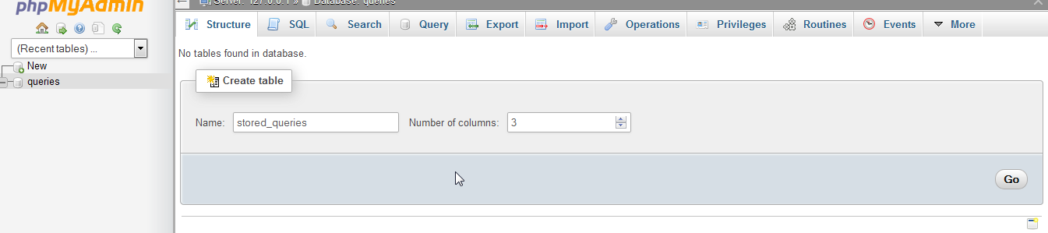
Step 5: Click on “queries” and add “stored_queries” as the name, “3” as the number of columns and hit “Go”
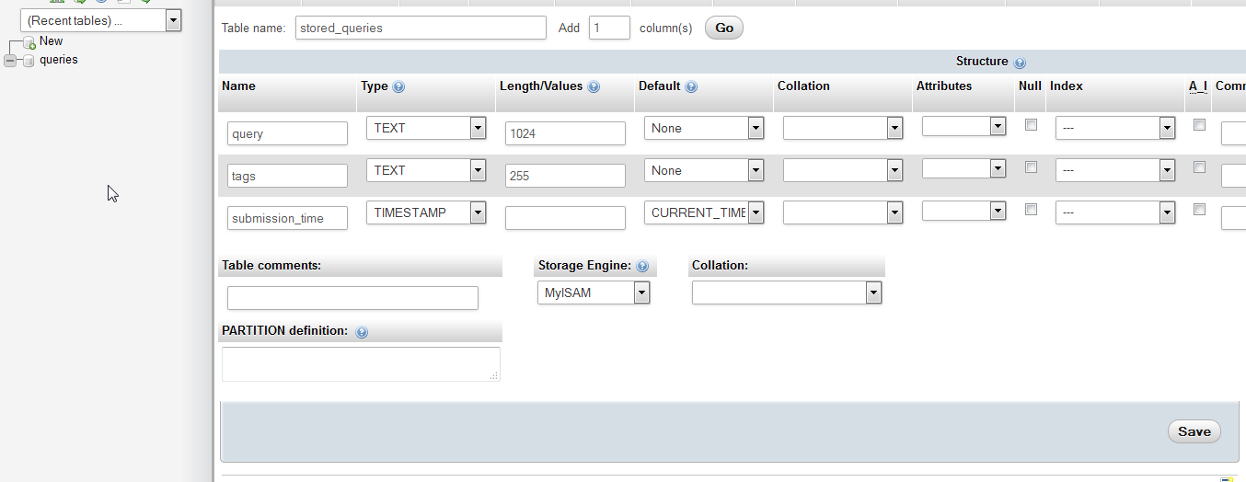
Step 6: Enter the definition for “query”, “tags”, “submission_time” as outlined in the following table. Make sure to “Save” before continuing on.
Name | Type | Length | Default
query | TEXT | 1024 | None
tags | TEXT | 255 | None
submission_time | TIMESTAMP |  | CURRENT_TIMESTAMP

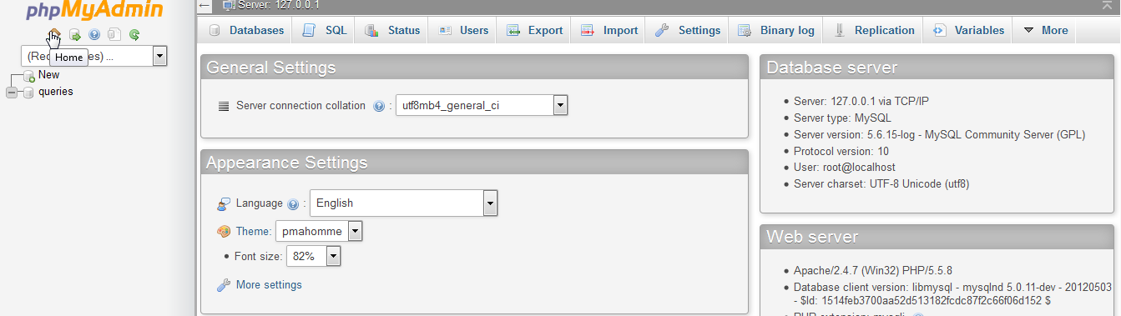
Step 7: Click Home

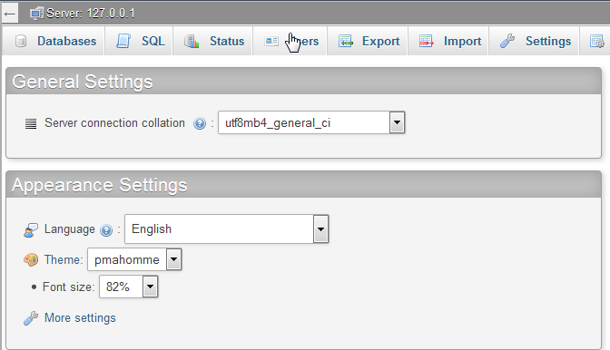
Step 8: Click “Users”
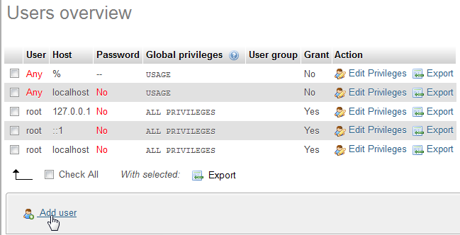
Step 9: Add a new user.

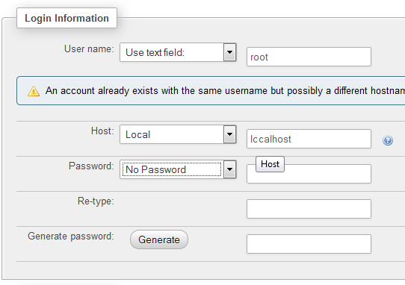

Step 10: Use these settings, ensure that the host is only “local”

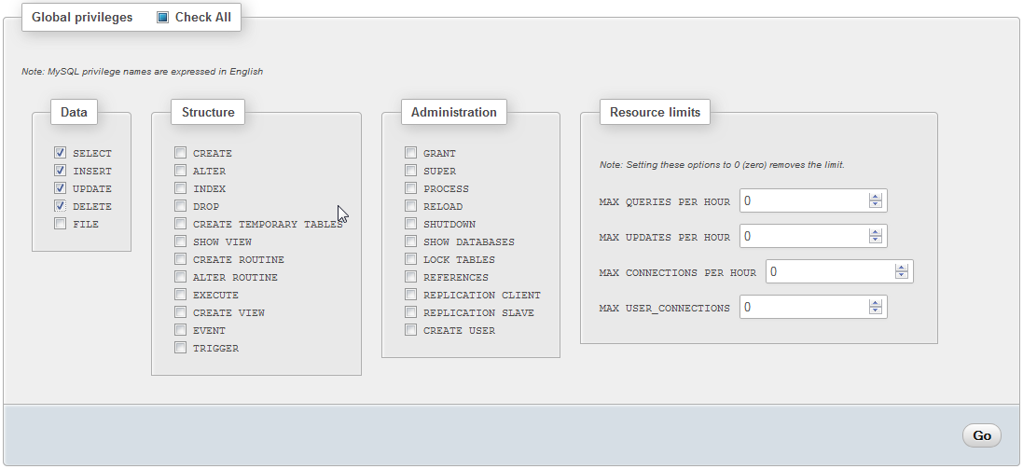
Step 11: Give the user this recommended set of permissions
Step 12: Press Go to create the account.

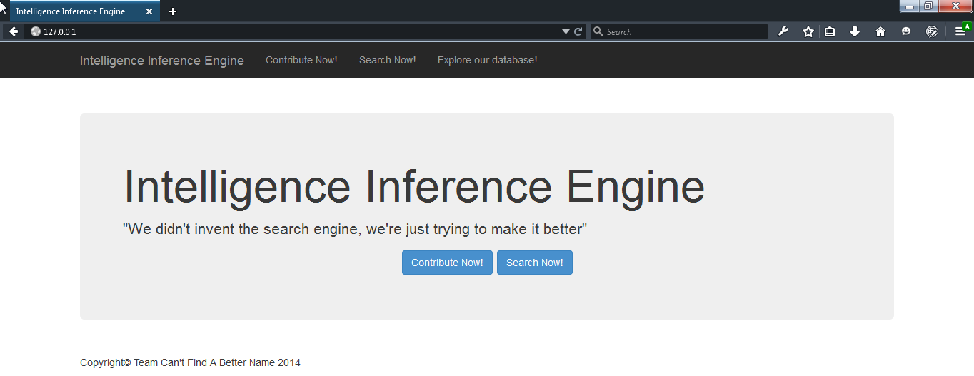
Step 13: Head over to 127.0.0.1 or the path to your machine.
You should be greeted by the intro page.

Closing Remarks

Congratulations, you have set up our software. We recommend you utilize the included User Guide to verify some basic functionality. We also recommend you allocate a reasonable amount of hard drive space as the database may expand too quickly and you may find yourself dealing with low memory warnings. We hope you get as much out of our software as we did out of creating it.

